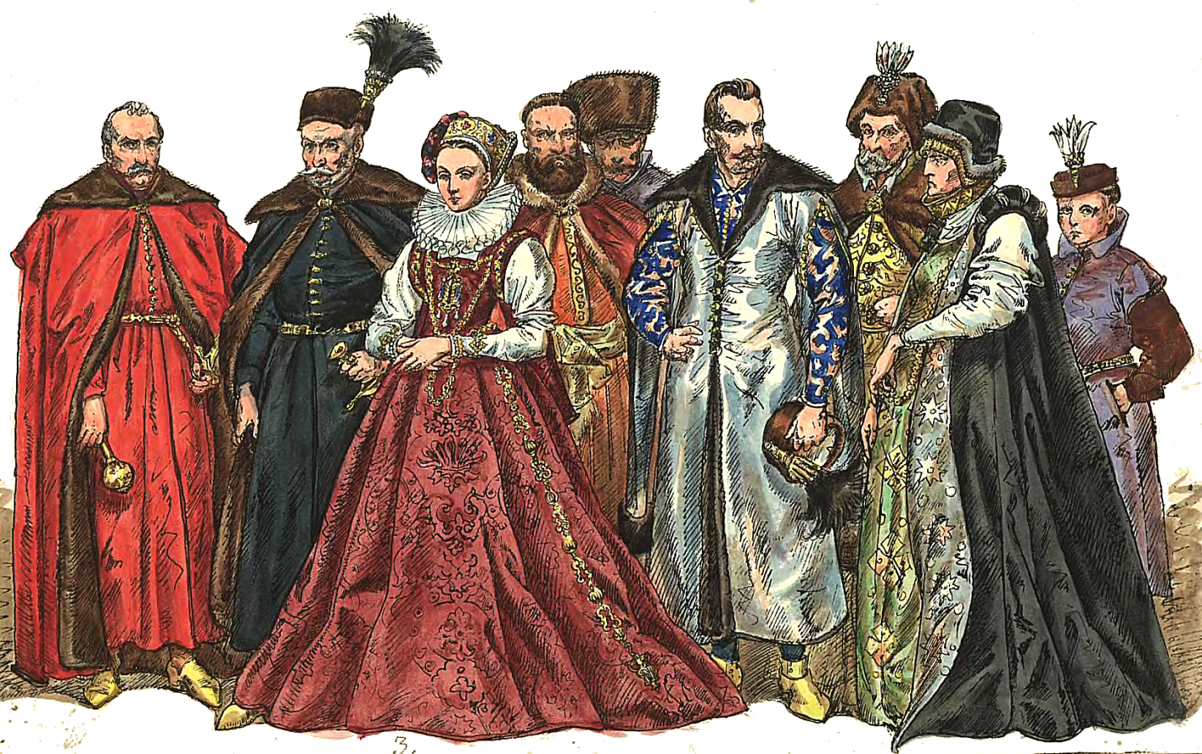

In an aristocracy, the country is ruled by the aristocrats. Aristocrats are usually the wealthiest or most educated people in a country. Sometimes there might be a large group of aristocrats in power, but there could be only a few. There is no voting in an aristocracy, but rulers are selected by who has the most power or education in the country. Aristocracies can be very large or small, and they can have large armies or small ones. Often in an aristocracy, a single ruler might become more powerful than the other aristocrats. When this happens, an aristocracy might become an empire or monarchy.

Aristocracy