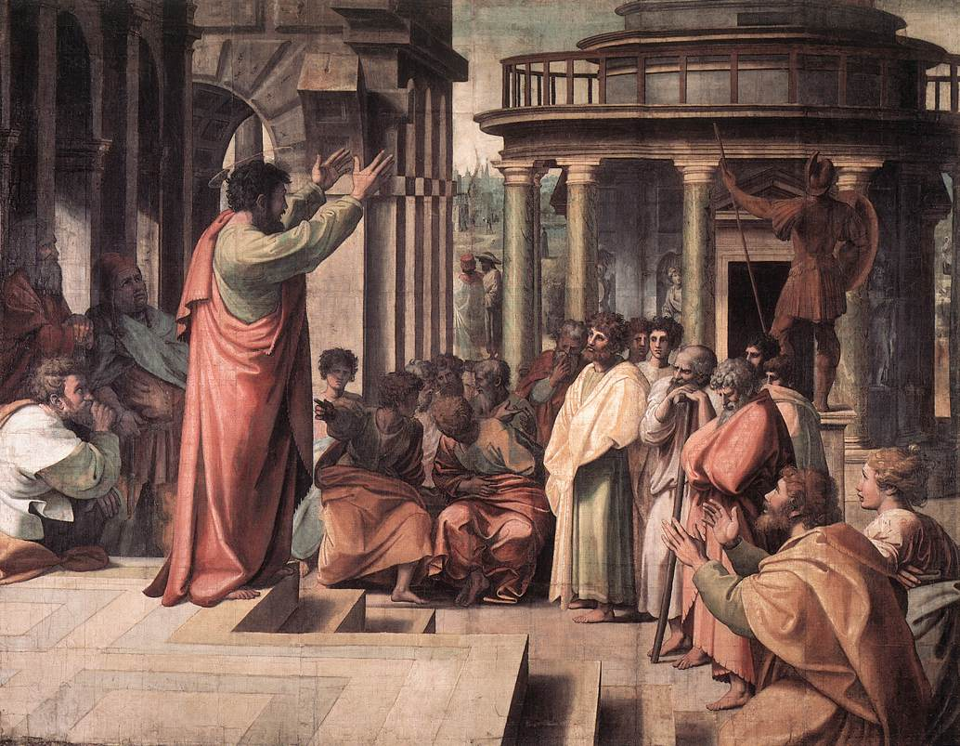

A democracy is based on voting. In a democracy, all people, or citizens living in a country, vote on what decisions to make. They vote on the laws, and on how life should be run in the country. Ancient Athens was one of the first examples of a democracy. Because the people get to vote in a democracy, they are usually very happy. However, it is very difficult for democracies to have large armies, because people do not often vote to create a large army. Democracies can be dangerous, because if one person can convince most people to vote on something, they can decide what happens. Democracies are also usually very small, and when they become larger usually become a different government type.

Democracy