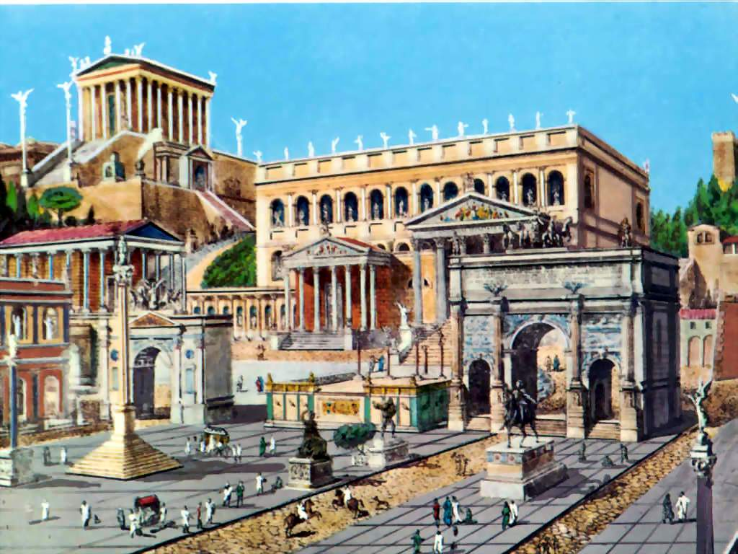

An empire is a huge area of land. It is usually ruled by an emperor. An emperor has total control over an empire. Some examples of empires are the Roman Empire and the Chinese Empire, but many more exist. In an empire, the emperor decides the rules of the empire, and makes every important decision. The people living in an empire have to obey the emperor. Sometimes empires are made up of many other smaller groups of people. These can sometimes be as small as a tribe, or can be a small country. Empires usually have very large armies to help control the empire and to defend the empire from outside enemies.

Empire