Fantasy Kingdoms Assignment

Type: Project/Large Assignment
Points: 50 Points

Student Objectives:

1. I can show that I understand major geographic features on a map
2. I can show the relationship between geography and people through history
3. I can show that I understand the major government types
4. I can show that I understand the relationship between government types and people through history

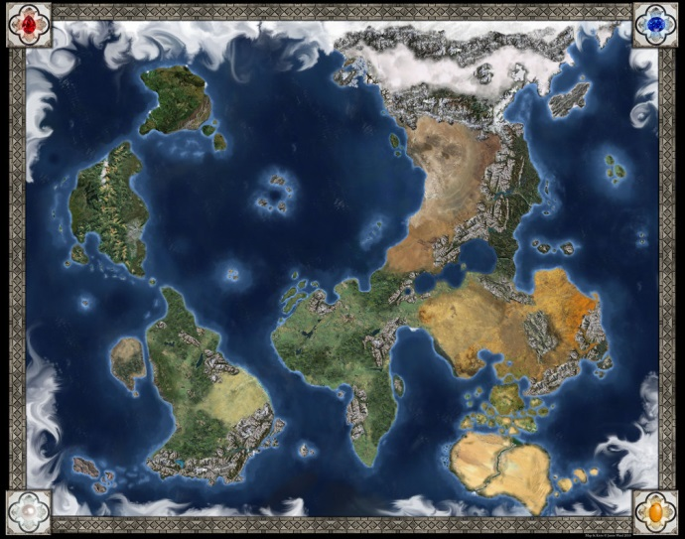
Description: We have been studying about geography and governments in class. Your task will be to create a fantasy world, complete with its own history. This history should show me the impact of geography and governments on people. Your assignment will include:

1. A Map showing at least 3 continents and the geographic features listed below
2. A 1-2 page description of at least 5 different governments/countries and their history in your fantasy world

Map: (25 points of total)
You will need to create a map, which must be colored showing the geography of your fantasy world. It will need to include

1. At least 3 continents
2. At least 2 mountain ranges
3. At least 3 major rivers
4. At least 2 large lakes
5. At least 1 large desert
6. At least 1 large tundra
7. At least 1 large forest/rainforest
8. At least 2 large peninsulas
9. At least 1 large island chain (archipelago)
10. At least 4 large islands

* All major geographic features need to be named

Written History: You will write a 1-2 page brief description of the history of your world. This history can be a description of your world at a certain point in time, or can describe the history over hundreds or even thousands of years. You will need to include:

- At least 4 government types that we have studied
- A brief description of the happiness and military strength of different countries/groups of people
- At least 2 large wars between countries/groups of people
- At least 2 religions, a brief description of each, and how they have shaped the world
- Anything else you want to include!

Grading:

Map: 30 points
Writing: 20 Points

