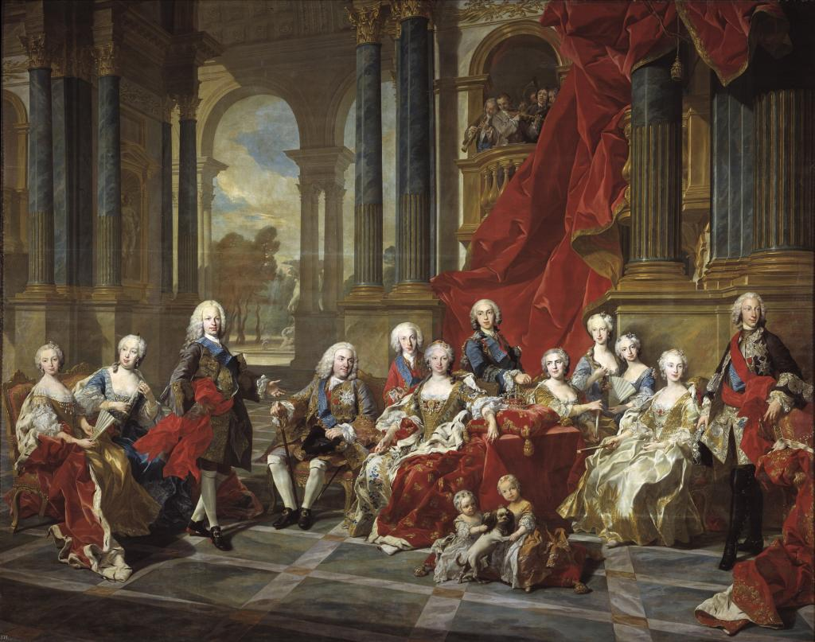

A monarchy is a government that is led by a king or queen. It usually is a large area of land, but not as big as an empire. A king or queen rules much like an emperor, however. They have total control, and decide the rules of the government. The countries of Europe during the Middle Ages were usually monarchies, and were run by powerful kings and queens. In a monarchy, usually a family runs the country, which means that a son or daughter of the king or queen will become the new king or queen after they die. Monarchs, or kings and queens, can become very wealthy. They can build large armies because of the wealth that the king or queen has.

Monarchy