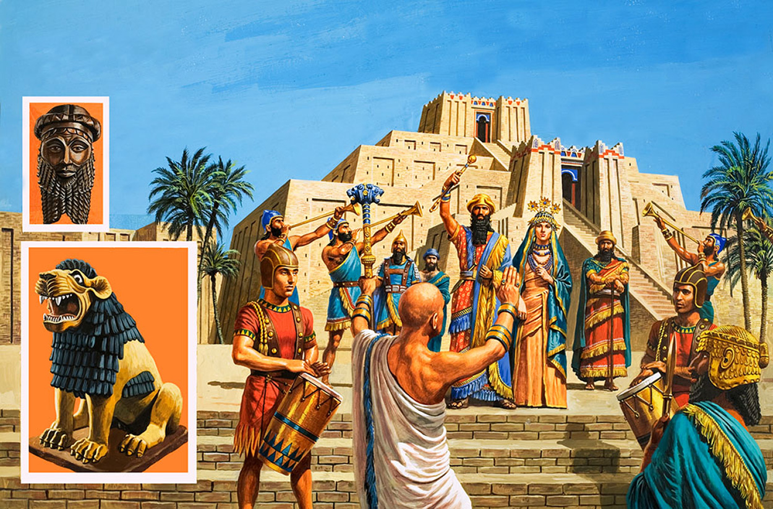

A theocracy is a government that is run according to a religion. The rulers in a theocracy can be the priests or powerful religious figures, or it can be a single ruler who rules. The rules in a theocracy are set according to the religion of the country. If the rules in a religion say that a person can or cannot do a certain thing, than the laws in a theocracy work the same way. Theocracies can often be very bad for people who do not follow the religion of the country. Often theocracies can have very powerful armies, because the soldiers believe very strongly in the religion. Because the people who follow the religion get to live well in a theocracy, they are often very happy.

Theocracy