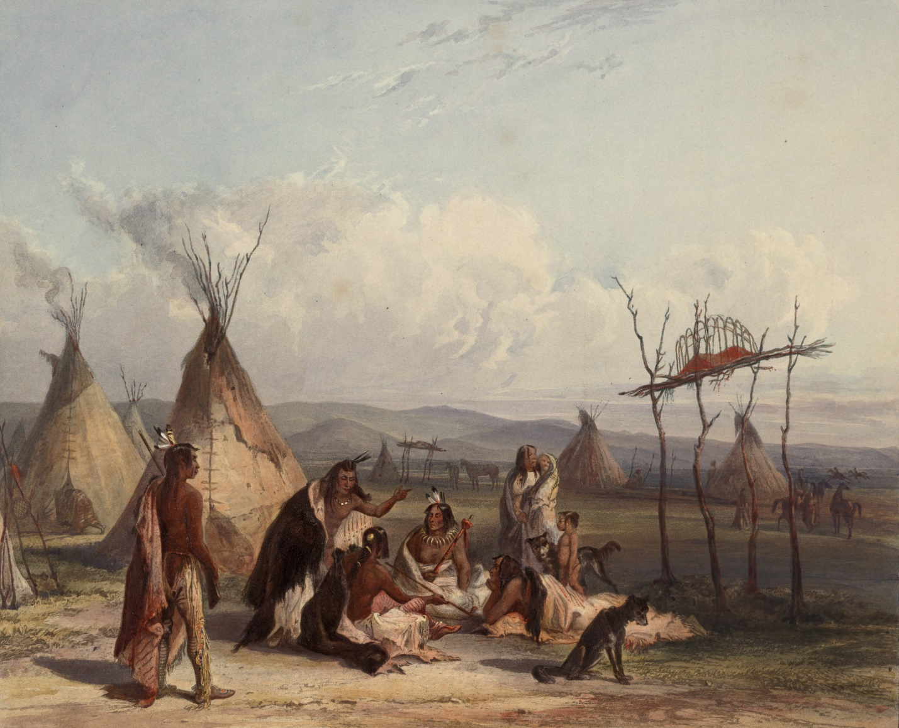

A tribal government is really not much of a government at all. Tribes are usually very small, and they are usually ruled by a powerful family. They can also be ruled by the most powerful warrior in the tribe. Laws in a tribe are usually only what the tribe has always agreed on in the past. Once a tribe becomes too large, they usually turn into another type of government. A tribe can be a good or bad thing to live in, depending on how nice the tribe’s leader is.

Tribal